Alexander Baldree, Max Jankowski, Aftabur Rahman, Jordan Dardar
Moffat Bay Marina Project
The Green Team Module 4 Screenshots
CSD460

When performing Query from the Java application that creates, seeds and queries the DB in Eclipse
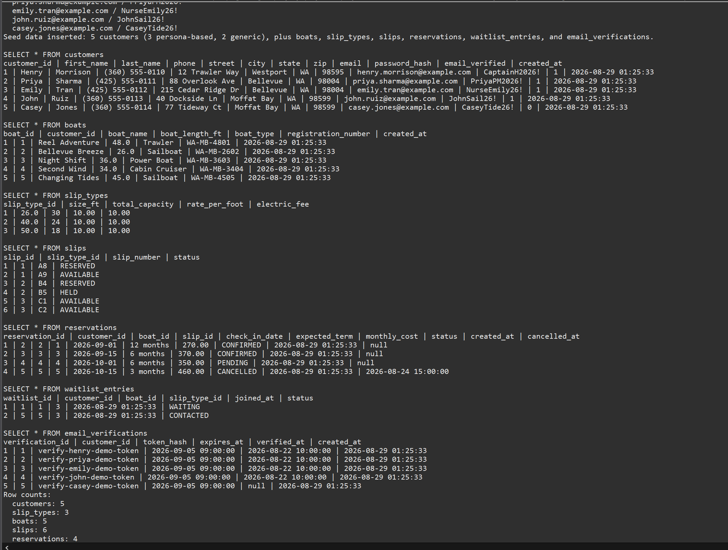

From the MariaDB Shell: customers, slip_types, and boats
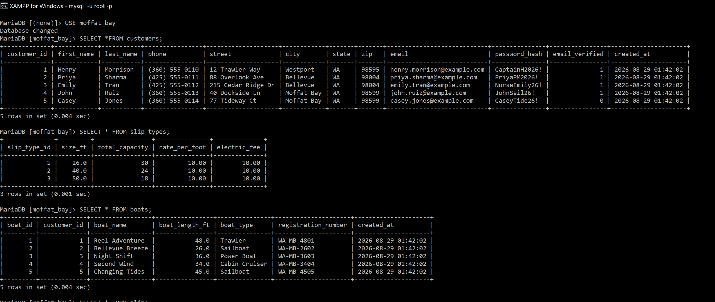

Slips, reservations, waitlist_entries and email_verifications.
